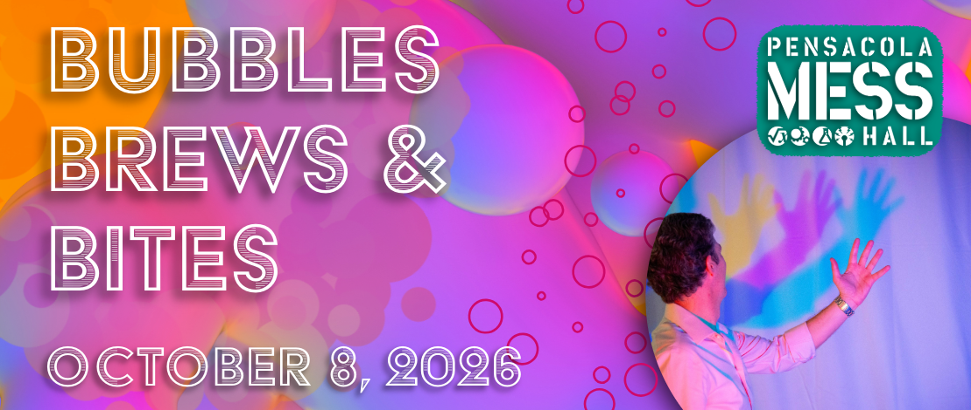

Join us for a special event combining Science + Food. This walk-about tasting event will feature local chefs sharing samples of gourmet food and the science of cooking.
Get ready for an entertaining and delicious science adventure!
Contact Megan Pratt (megan.pratt@pensacolamesshall.org) with any questions.

Sponsorship Opportunities
Title Sponsor |  | $10,000
8 VIP Tickets to event
24 drink tickets
Name in the event title
Signage at personal VIP Table
Logo on all promotional materials
10 social media posts, starting 10 weeks out from event, customizations available for 2 posts (per request)
Title sponsorship recognition by Emcee
45-second commercial played at the event during Emcee recognition
Biggest logo on PPT presentation scrolling throughout the evening
Right of refusal to offer swag or promotional items for the event (to be received at least 3-weeks prior)
Customizations available (per request)
Logo on Website for 12 months
Right of refusal for next year’s title sponsorship

Gold Sponsor |  | $5000
6 VIP Tickets to event
18 drink tickets
Signage at personal VIP Table
Logo on all promotional materials
8 social media posts, starting 8 weeks out from event
Gold sponsorship recognition by Emcee
Logo on PPT presentation scrolling throughout the evening

Bar Sponsor |  | $3000
Signage at Bar recognizing your business
Signage at Personal VIP Table
4 VIP Tickets
12 drink tickets
Logo on all promotional items
7 social media posts, starting 7 weeks out from event
Name on PPT presentation scrolling throughout the evening
Bar sponsorship recognized by EMCEE

Silver Sponsor |  | $2500
4 VIP Tickets to event
12 drink tickets
Signage at personal VIP table
4 social media posts, starting 4 weeks out from event
Logo on PPT presentation scrolling throughout the evening
Logo on all promotional items
Silver sponsorship recognized by emcee
Bronze Sponsor |  | $500
2 Tickets to event
6 drink tickets
2 social media posts, starting 2 weeks out from event
Logo on PPT presentation scrolling throughout the evening
Logo on all promotional items

Individual Tickets |  | $80

The Pensacola MESS Hall is a 501(c)3 organization. Our mission is to inspire curiosity, experimentation, and creative problem solving through exploration of math, engineering, science, and stuff. Our Tax ID number is 45-5211853. A copy of the official registration and financial information may be obtained from the Division of Consumer Services by calling toll-free within the state. Registration does not imply endorsement, approval, or recommendation by the state. FDACS’s toll-free number is 1-800-HELP-FLA (435-7352). The FDACS website is www.800helpfla.com.

